Equido Clinics Information Pack

WHAT ARE ROUND PENS AND WHY DO YOU USE THEM?

Round pens - These can be permanent or temporary circular structures 50ft diameter and is used for working your horse either loose or under saddle. The round shape allows you to work the horse in a relatively safe environment and also allows you to keep your horses focus, where as, unlike an arena, there are no corners for the horse to lose balance and focus in. It's a more user friendly size which is beneficial when working your horse loose especially when your starting a young horse . They can also be used for long lining - ( training your horse with two lunge lines attached to the bit, mimicking the aids you would use with your reins whilst working them from the ground ), as a safe area for starting a horse under saddle and can be used for free schooling your horse.

WHAT IS GROUNDWORK AND WHY DO WE NEED IT?

Groundwork - This is a series of exercises designed to create a structure that can be taken into your ridden work teaching by teaching the horse flexion and a soft feel which can take the horse forwards into the more advanced work i.e lateral work, turn on the haunches, halfpass and backup. We also work on the ground in order to trouble shooting, it allows us to deal with issues such as:- loading issues, planting, head shy, tack introduction, starting under saddle and long lining.

WHAT DOES THE RIDDEN WORK CONSIST OF?

Ridden – Dressage/Flatwork, jumping, western

Equido have a team of top instructors to help you with your riding skills from novice to advanced. All instructors have competed at high levels in their chosen disciplines for many years and bring practical experience to you the student.

Where possible the instructors will teach you from horseback to allow immediate and clear demonstration of what is required. (This may not be possible for the jumping classes or at some venues). All of our instructors are open to questions from participants and audience alike and please feel free to chat to them before or after the workshop about any issues you may have or anything you would like to work on during the session.

Rider level definition FLATWORK

Beginner: Rider should be able to walk, trot, halt and turn.

Novice: Rider should be able to walk, trot, canter and understand the principles behind working a horse in an outline.

Intermediate: Rider should be able to work a horse in an outline with a light contact and be able to perform basic lateral work eg turn on the haunches, shoulder in, leg yield and simple changes.

Advanced: Riders should be able to perform lateral work to a more advanced level eg extensions, half pass, flying changes and pirouettes.

Horse level definition FLATWORK

Beginner: Horse should be able to walk, trot, halt and turn. The horse may not have ridden in company before and this is a great opportunity to teach your horse in a safe secure environment.

Novice: Horse should be able to walk, trot, canter and understand the principles behind working in an outline. The horse should have been ridden in an enclosed space with other horses.

Intermediate: Horse should be able to work a horse in an outline with a light contact and be able to perform basic lateral work eg turn on the haunches, shoulder in, leg yield and simple changes.

Advanced: Horse should be able to perform lateral work to a more advanced level eg extensions, half pass, flying changes and pirouettes.

Rider level definition. JUMPING

Beginner: Rider has never jumped or is nervous of jumping.

Novice: Rider has had some basic jumping lessons and introduced to grid work.

Intermediate: Rider is competent jumping grids and courses of up to 85cm.

Advanced: Rider should be competent jumping grids and courses of at least a meter.

Horse level definition. JUMPING

Beginner: Horse has never jumped or is nervous of jumping.

Novice: Horse has had some basic jumping and has been introduced to grid work.

Intermediate: Horse is competent jumping grids and courses of up to 85cm.

Advanced: Horse should be competent jumping grids and courses of at least a meter. Horse may be competing in affiliated show jumping or one day eventing.

WHAT IS EQUIDO?

Equido is a concept which uses modern horsemanship techniques. It has been our goal to help horse owners and horses find a common ground of mutual understanding and trust so they can work together as a more effective team . Our highly experienced team of instructors are here to guide you and your horse forward working in a non confrontational manner we will help you become more disciplined in all aspects of your horsemanship.

Also available is the Equido training system, government recognized qualifications certified by LANTRA which use industry standards in horse care, blended with modern horsemanship knowledge as you would see demonstrated at our clinics. Equido is available as a home study course or as a concentrated learning course these courses are available at Ross Dhu Equestrian the home base of Equido, we also work in partnership with Argyle collage U H I - ( University of the Highlands and Islands ).

Times and location - Map of how to get there, times, indoors or outdoors, what to bring - seating ect, parking, catering, do's and dont's.

HOW DO I BOOK AND PAY?

Payment - Deposit and balance ect. It is Equido's policy that when booking on any course/clinic that a deposit of half the total of the full payment be received along with your application form 3 weeks prior to the clinic and full balance received no later than 14 days prior to the course/clinic. All deposits will be non refundable due to venue costs and overheads. All cheques should be made payable to Equido Horsemanship.

For further information on any of the above please contact us at www.scottishhorsehelp.co.uk.

We look forward to meeting you and your horse.
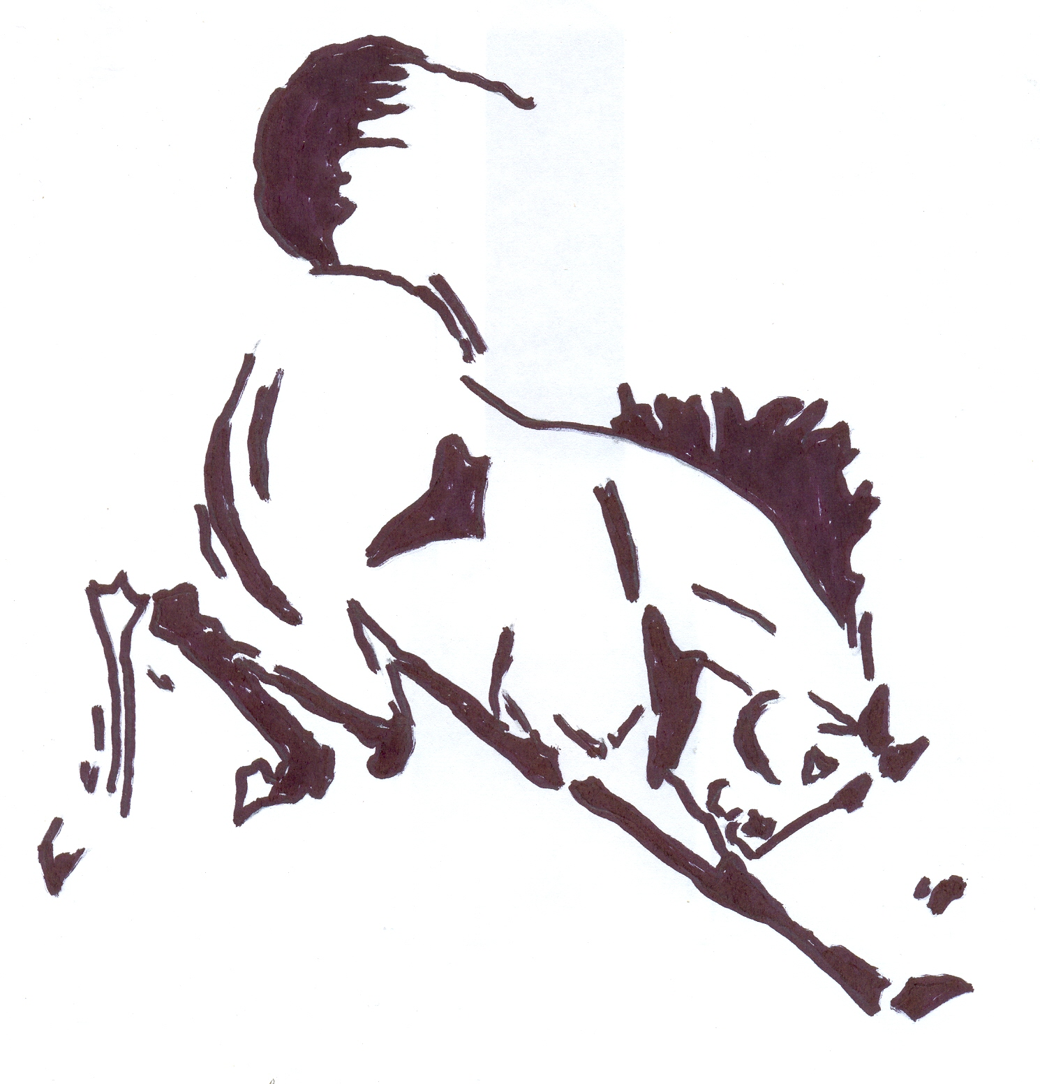
EQUIDO TWO DAY DRESSAGE CLINIC
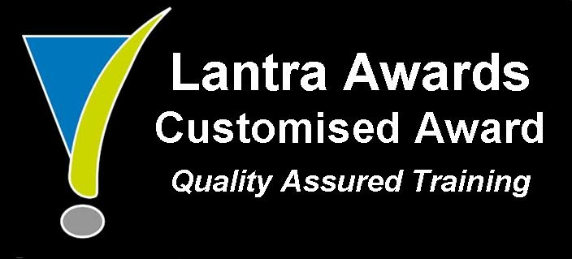
Equido two day clinic teaching the innovative and unique Equido ethos.

Venue: Ross Dhu Equestrian Dates: Saturday 14th and Sunday 15th May 2016

Morning Group Sessions - these will cover what is required to gain maximum points in the dressage manoeuvres
Lunchtime Lecture - this covers the concepts of classical riding and what we are trying to achieve.
Afternoon Group Sessions - these will give all riders a chance to go over their chosen tests and to work through any problem areas they might have.
Day two will be a small competition in tests one to four with coaching given

Please return form and deposit to:-
Ross Dhu Equestrian
Sunnyside Farm, Sunnyside Road
Quarter, Larkhall
ML9 1RB

Cheques made payable to Equido Horsemanship Ltd

Costs for the course are:- £90 for one day and £160 for two. Course deposit required £50 at time of booking.
Spectators fees are :- £20
For further information please contact:-
Morag Higgins – Tel 01698 886 492 Mob: 07979741672
Closing date for entries will be :-

Name:
Address:

Tel:
E-mail:

Horse Level of Training:

Rider Level of Training:

Number of Days attending:

Course deposit enclosed: £

