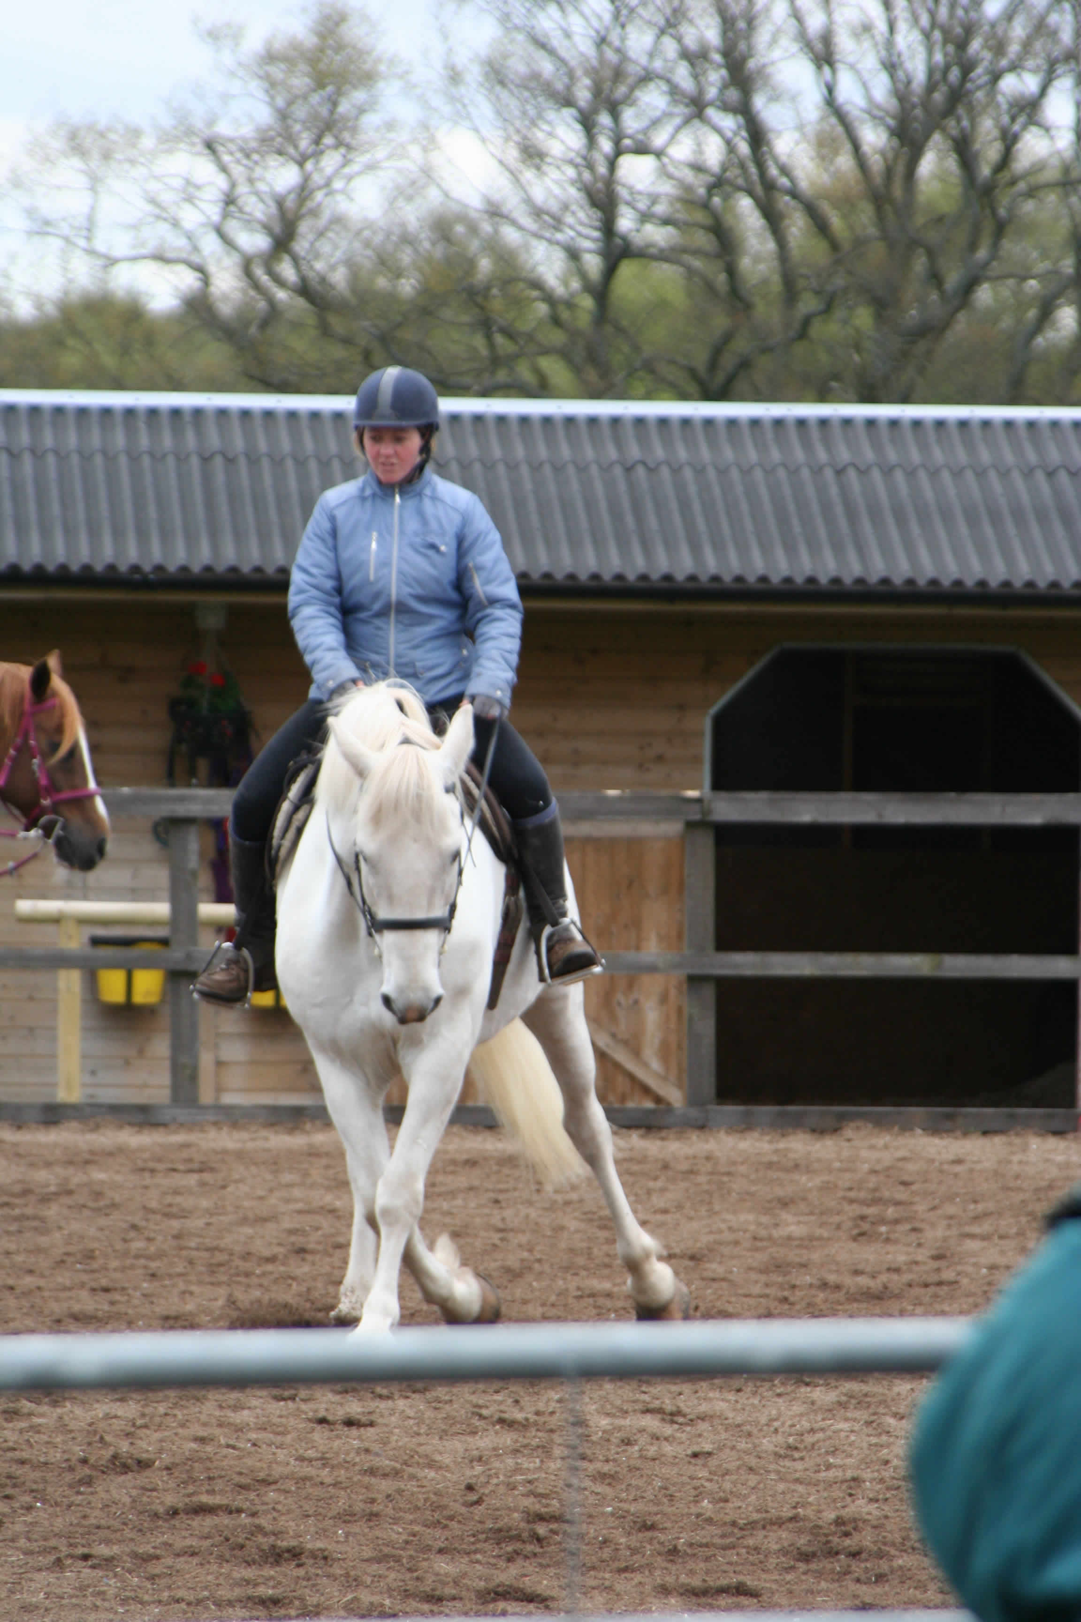

West Coast and Islands:-
Fiona Hillis Mob 07876324498, e-mail - fionahillis@aol.com

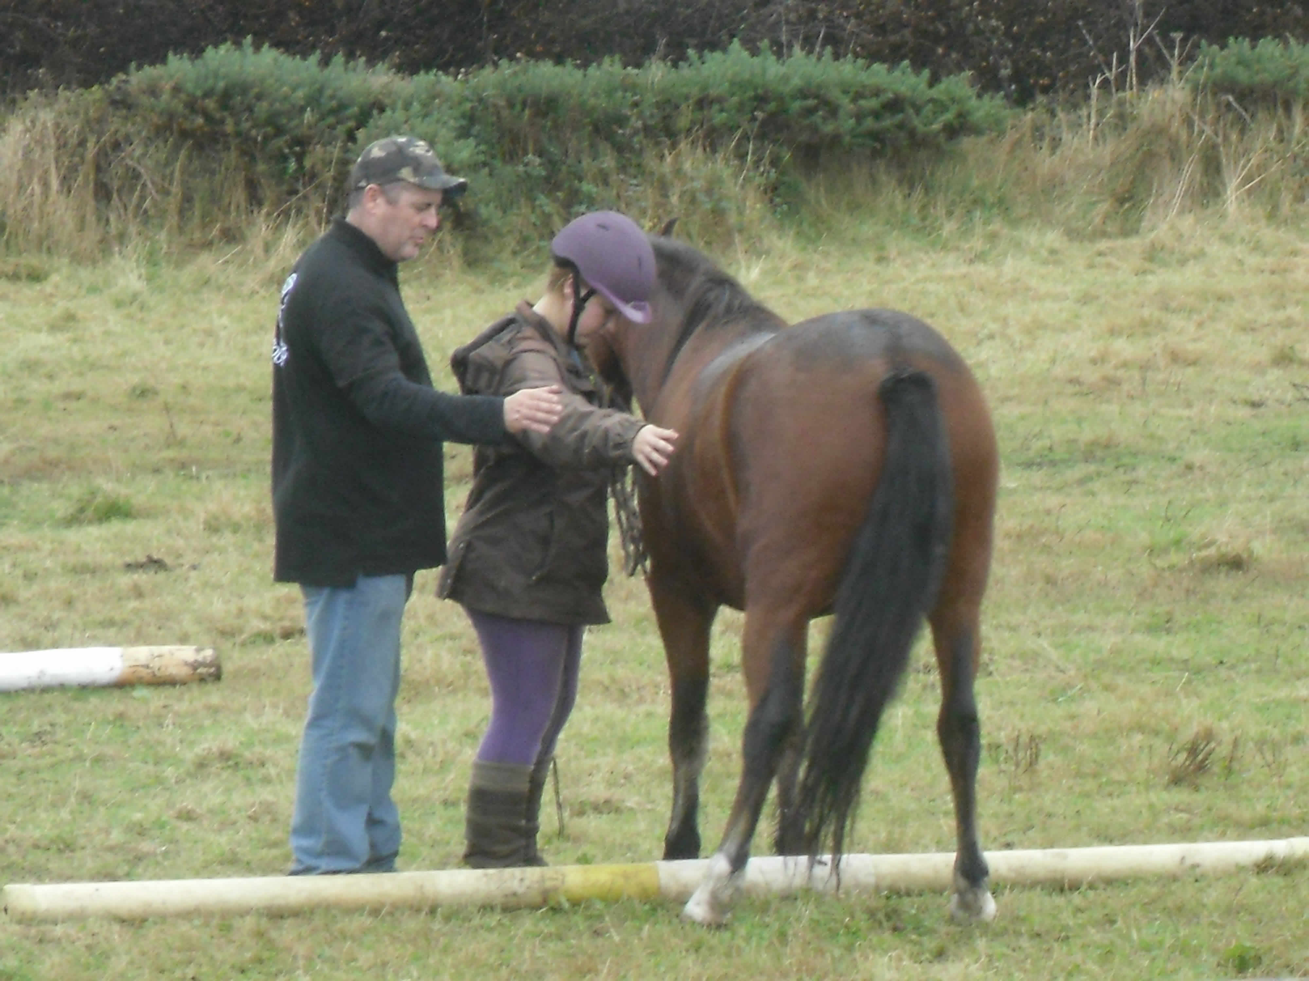
Central Region and South:-
Mark Higgins Mob 07585168519, e-mail - markhiggins66@hotmail.co.uk

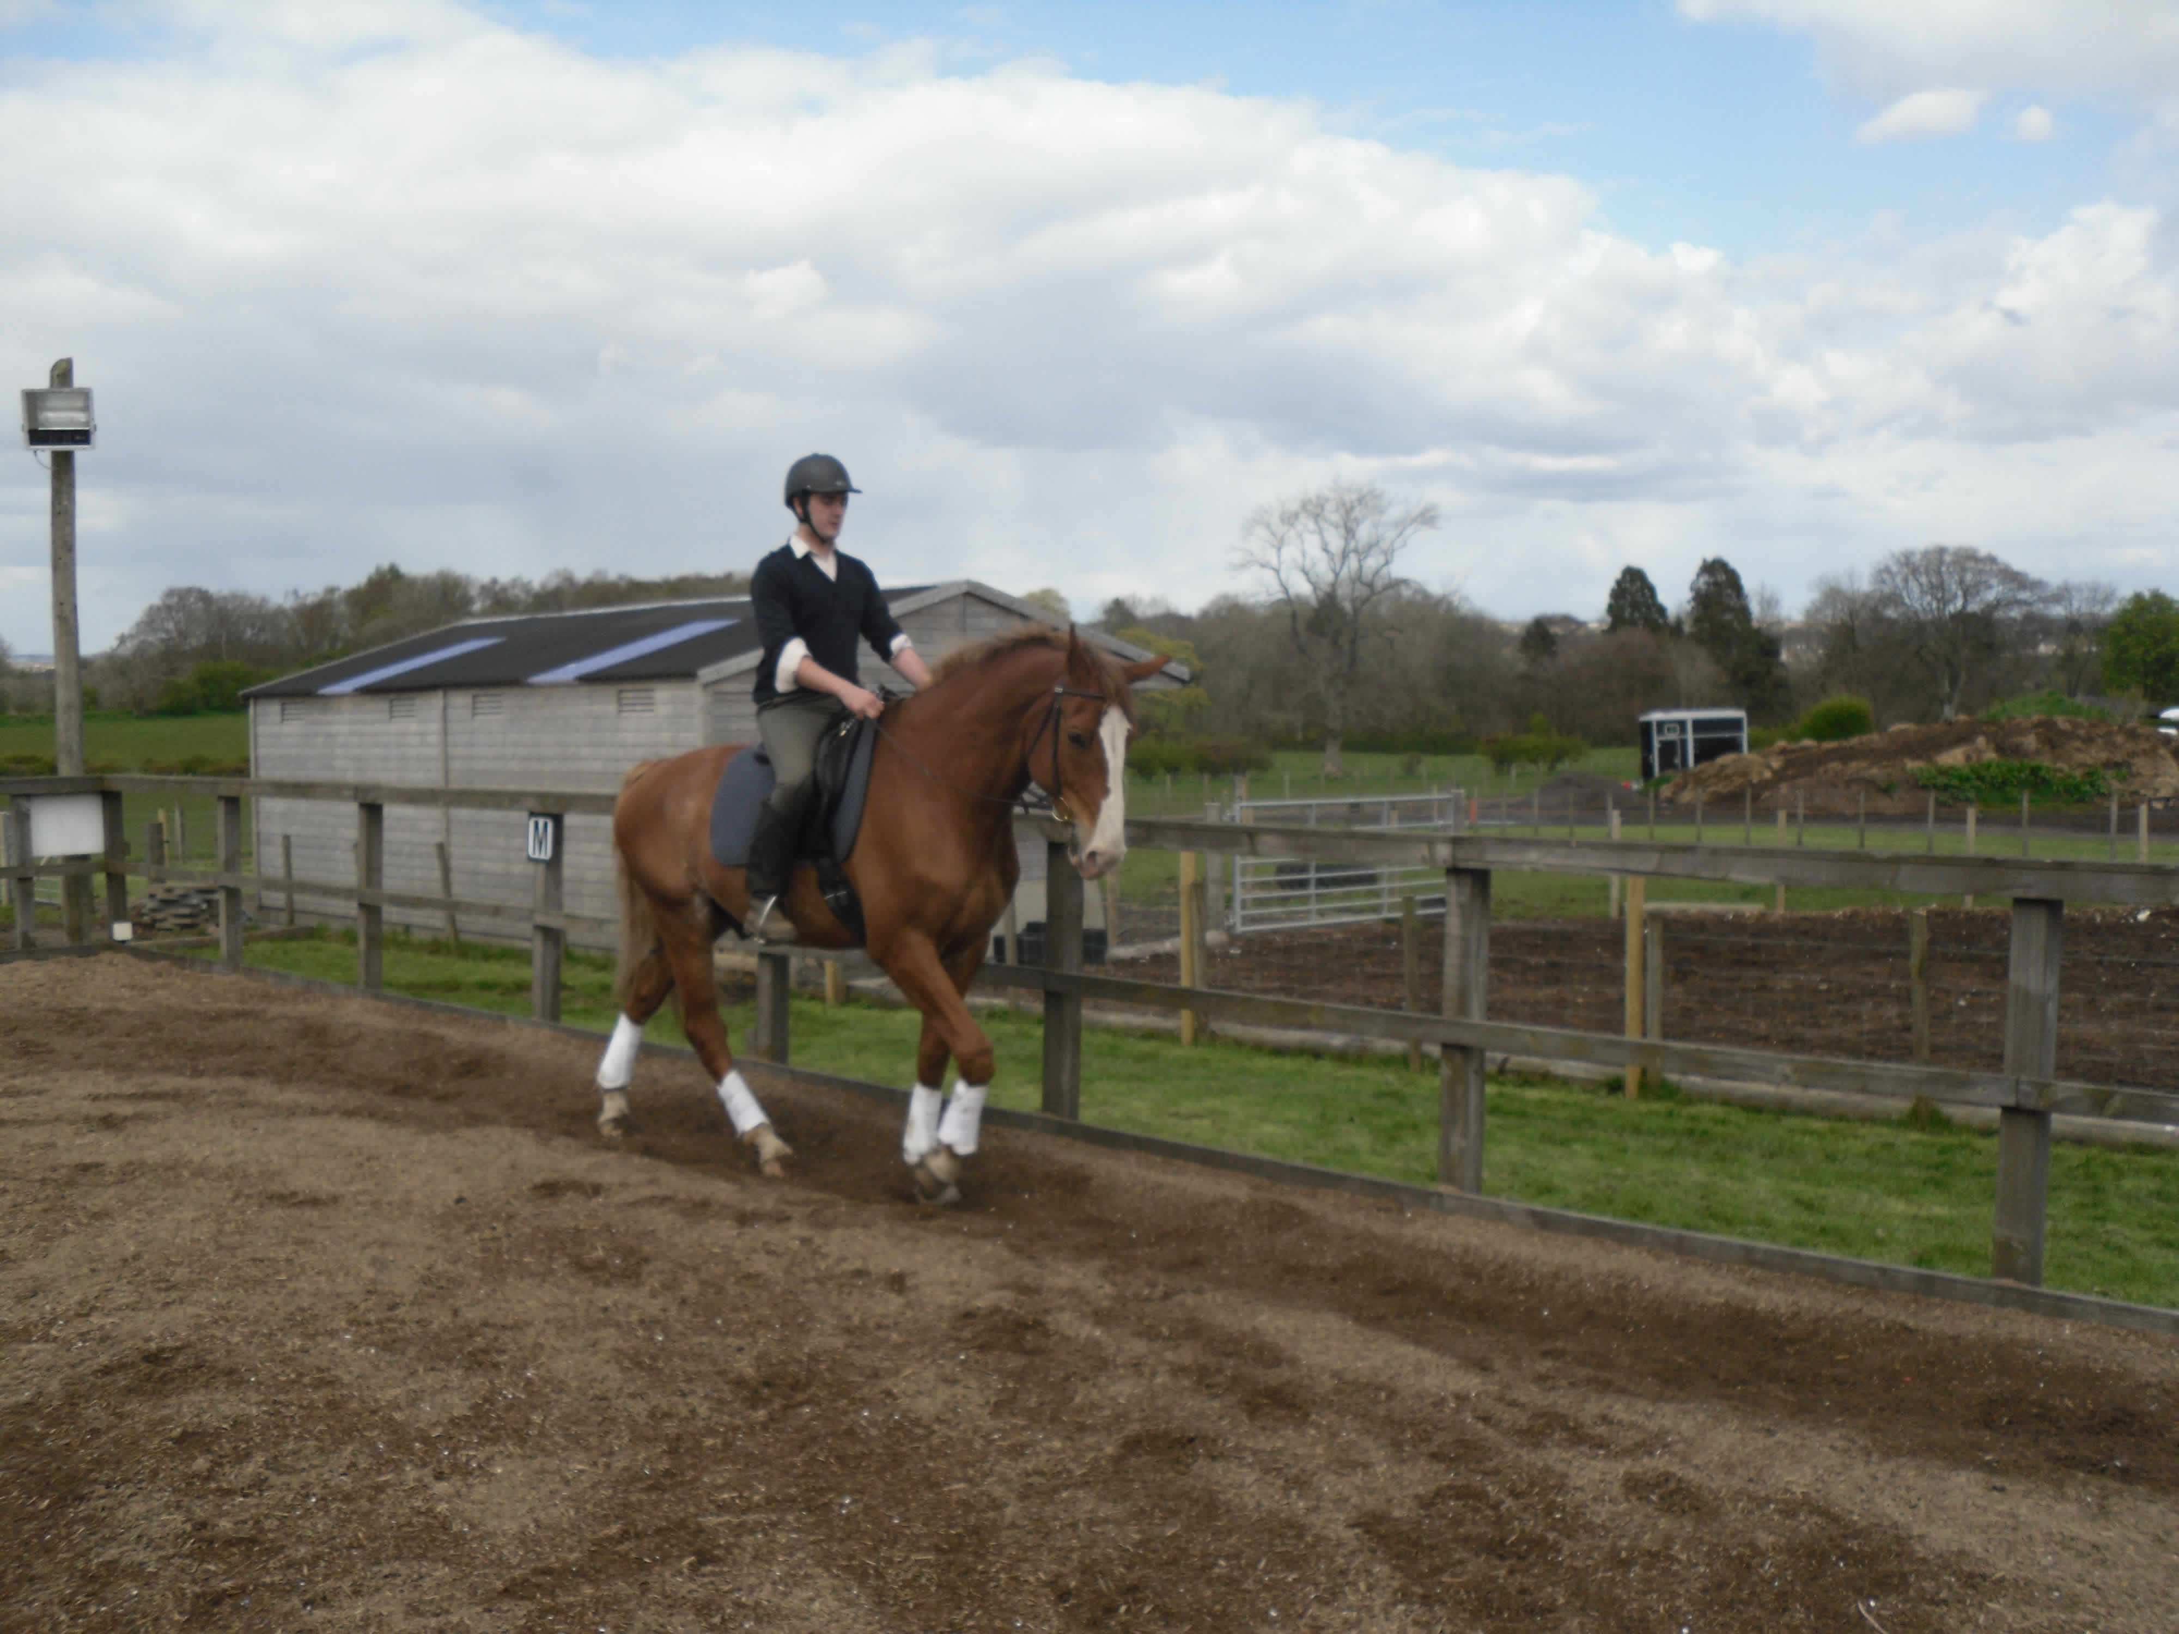
Highlands and Northwest/east Coast
Ross Pirie Mob 0754863805, Tel 01887866218, e-mail - ross.pirie@hotmail.co.uk

